RBSP EFW
Preamp HA5127 TID
Test Report

RBSP_EFW_TR_004

David Curtis, U.C. Berkeley RBSP EFW Systems Engineer

Document Revision Record
Rev. | Date | Description of Change

Distribution List
Name | Email
David Curtis, Systems  Keith Goetz, PM  John Bonnell, Inst CoI  Jane Hoberman, BEB EE  Ron Jackson, QA | dwc@ssl.berkeley.edu  goetz@umn.edu  jbonnell@ssl.berkeley.edu  jch@ssl.berkeley.edu  ronj@ssl.berkeley.edu

TBDs
Identifier | Description

Reference Documents
Ref | Doc Number | Title

Overview
A Total Ionizing Dose radiation test was performed for the RBSP EFW project on five HA7-5127/883 (Lot Date Code R0840) opamps at National Semiconductor Gamma cell 220 radiation facilities in Santa Clara, CA, on December 8, 2008. Opamps were tested at 10, 20, 30, 40, and 50 krads (Si), and after 24 and 48 hour room temperature biased anneal, and finally after another 120 hours at 100C biased anneal. Some parametric changes were seen during test, most of which were reversed by anneal. All devices were in spec post-anneal.

Test Procedure
The devices were characterized prior to radiation and immediately after each dose (and after the anneal periods) using the opamp characterization setup described in section 2.1. The units were biased during dosing at +/-10V (100mA limit) using the circuit shown in Figure 1. The 5 parts were radiated simultaneously, and the total supply current was monitored during the test – no significant change was seen. Radiation test facility records are included in Appendix B, showing dose levels and rates.

Figure 1 – Biasing circuit

Opamp Characterization
At each step in testing the opamps were fully characterized using an LTS2020 test station with an LTS2100 Opamp family board and an LTS0614 low leakage socket adapter (calibrated Test Tech, 5/21/2008). This test station makes the following measurements (with the listed accuracies) and verifies the results are within the data sheet specifications. The values of the parameters are also recorded to look for any significant charges.

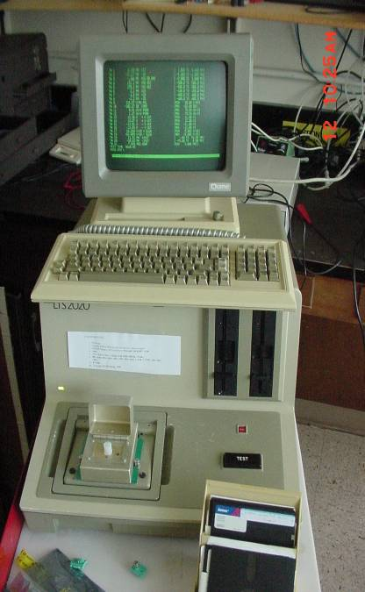
Test 1. V+ supply operating current
Figure 7. LTS2020 OPAMP Tester
±0.2% + 10μA
Test 2. V- supply operating current
±0.2% + 10μA
Test 3. Offset voltage
±0.25% + 5μV
Test 4. Offset Current
±5% + 25fA
Test 5. Bias Current
±5% + 25fA
Test 6. Large Signal Voltage Gain
±1.5% + 1V/mV
Test 7. Common Mode Rejection Ratio
±0.25% + 0.1dB
Test 8. Power Supply Rejection Ratio
±0.25% + 1μV/V
Test 9,10. Output Voltage Swing, 2kohm load
±0.4% + 1mV
Test 11,12. Output current source/sink
±0.2% + 10μA
Test 13,14. Slew Rate
±10%
Test 15. Gain Bandwidth Product.
±10% + 10kHz

Appendix A includes part of the HA5127 data sheet showing the operating limits for comparison. Note that it was found that a 100pF compensation capacitor was needed between the –IN and OUT pins, to stabilize the part during performance testing.

A control part (unit C) was measured prior to measurements of the TID test devices to verify that any change is not a result of a change in the LTS2020. Each unit was measured twice. All testing was done at room temperature.

The tester was initially set to measure within the data sheet limits. When a parameter exceeded those limits, the limits were expanded in order to measure the actual value without saturation. Bias current is the only parameter that exceeded limits, requiring a range adjustment during the test.

Test Results
The units were all in spec prior to radiation dosing. Some parametric changes were seen, particularly on IOS, IB, and AOL, even after 10krads, but all remained in spec. The bias currents gradually increased with radiation for all devices, with Unit 3 going out of spec after 20krads, Unit 2 after 30krads, and the rest after 40krads. The largest bias current seen was 212nA (compared to a limit of 80nA) on Unit 3 after 50krads. No other parameter (including IOS) exceeded limits on any part up to 50krads, though there were some variations – notably AOL decreased significantly, approaching the lower limit (700 V/mV) for all 5 units after 50krads.

The devices were allowed to anneal for 24 and 48 hours at room temperature. The parameters gradually returned towards normal, with units 1, 4, 5 in spec after 24 hours, and all but unit 3 in spec after 48 hours. After another 120 hours of anneal at 100C all devices were well within spec, with the larges bias current being 22nA (compared to a pre-dose level of ~8nA and a limit of ~80nA). AOL also recovered to ~1900 V/mV, compared to pre-radiation levels of ~2800V/mV and a lower limit of 700 V/mV.

Detailed measurement results are presented in Appendix C.

Appendix A – HA5127/883 Data Sheet
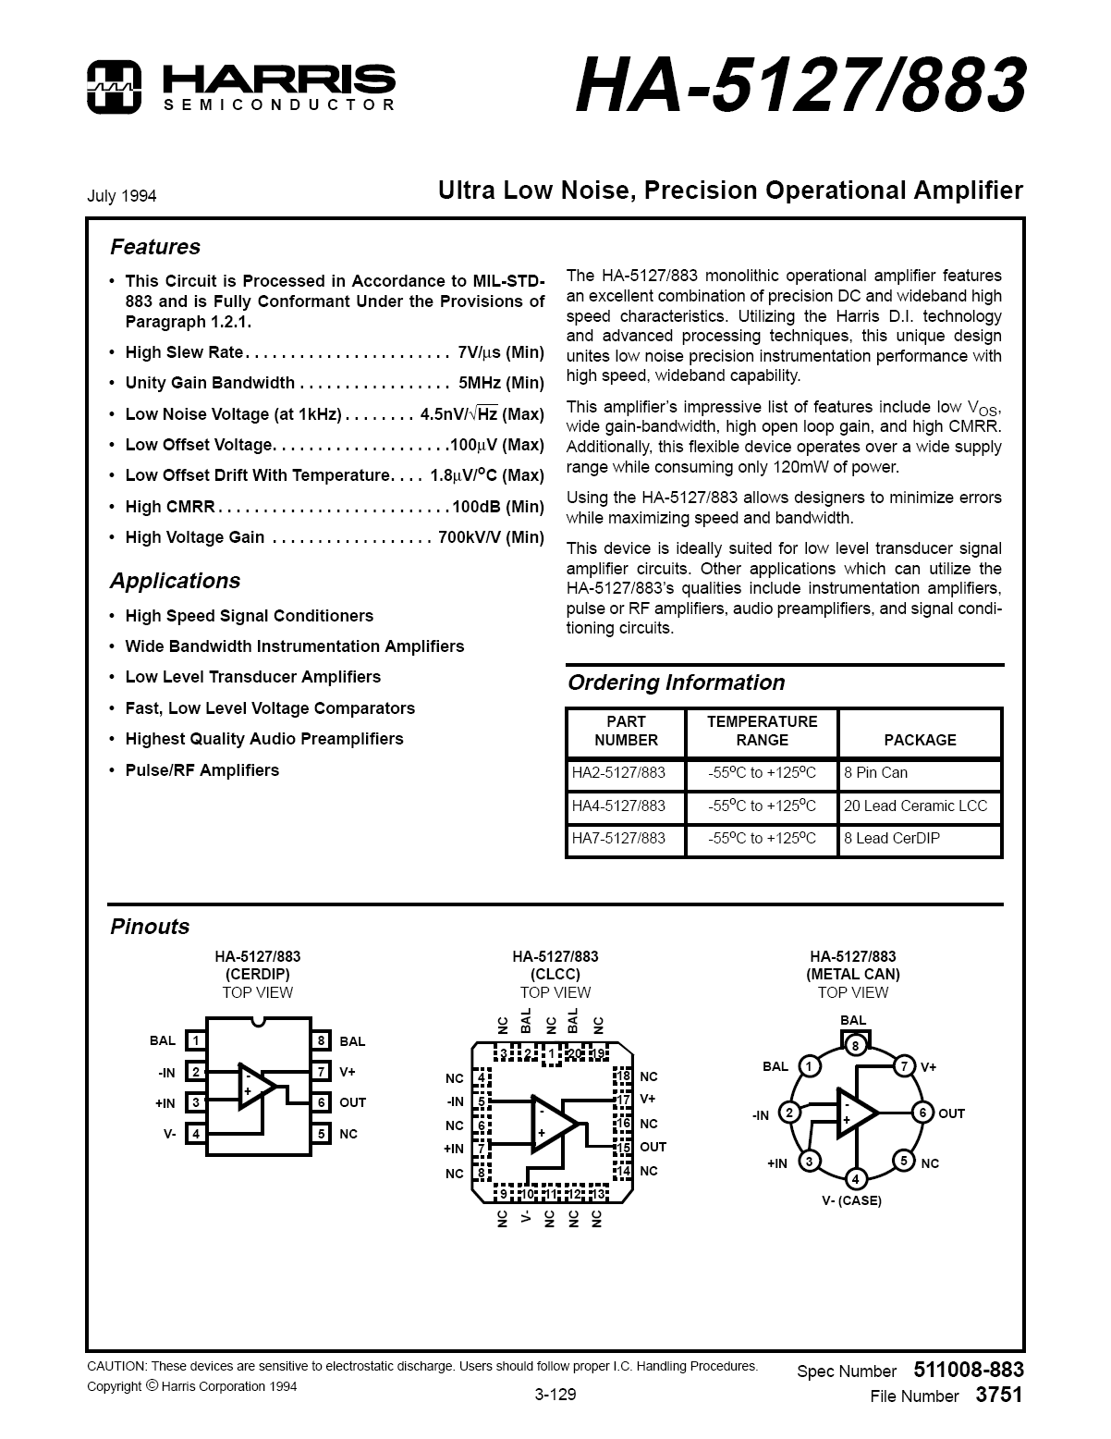

Appendix B. Radiation Facility Records

Appendix C - HA5127 Test Results

